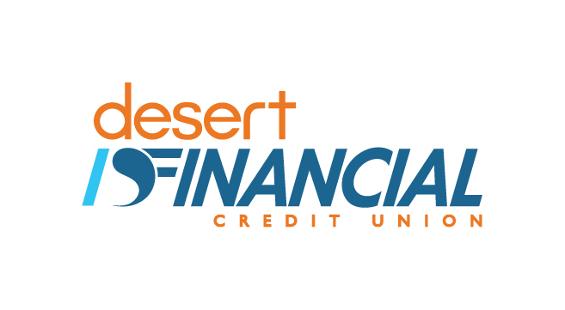

Adult Financial Wellness Program Overview
  - Desert Financial has been committed to financial education for many years. As a credit union founded by educators nearly 80 years ago, education is important to us. Our workshops are offered at no cost because we want to lend a helping hand in making our communities stronger.
A 2017 study conducted by the Consumer Financial Production Bureau found that a “large percentage of people in the US are financially fragile – roughly one third of individuals have difficulty making ends meet.” These findings are some of the reasons why we continue to make our classes available to organizations and the community at-large. Our hope is that consumers will begin to engage in routine money management practices, have positive financial attitudes, behaviors and skills. We want to help transform lives by providing tools and resources to help people achieve financial success.
We have provided workshops in partnership with many organizations throughout the valley for years to help support their work in the community. Below are a few of the agencies we’ve partnered with to provide workshops for staff and their clients.
- Native American Connections
- City of Phoenix Head Start Program
- Parent groups at schools
- Community centers
- St Joseph the Worker

Thank you for your interest in our Financial Wellness Program. For more information, or to request a class for your group please contact us for a class request packet. The class request packet includes:
- Class request form
- Service Level Agreement
- Menu of workshop topics

Sulie Richardson
Community Education Program Manager
602-335-4312
sulie.richardson@desertfinancial.com

