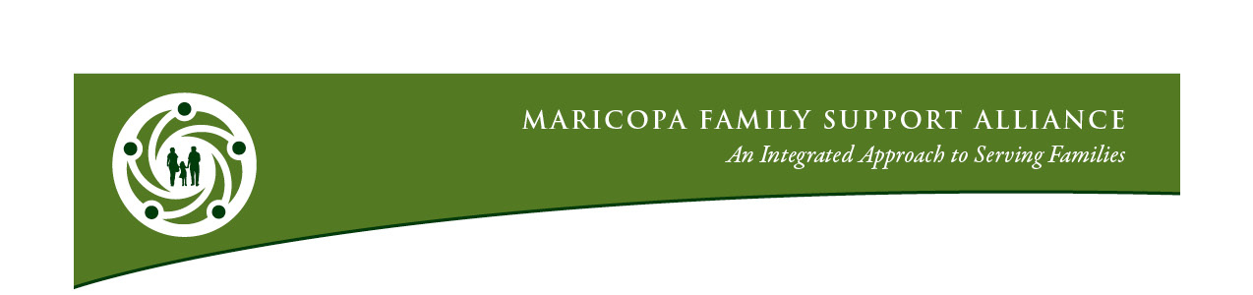

Commitment to Participate
Introduction
The Maricopa Family Support Alliance was formed in April 2011 with the intent to build a collaborative Alliance of family support providers with the capacity to serve families through an integrated system of services. The Alliance members share a passion for serving people, a commitment to long-term collaboration, cooperation and a focus on engaging and empowering families. The Alliance has a bias for action especially those actions that directly result in improving outcomes for families.

Vision: “Families prospering in supportive communities.”

Mission: The Mission of the Maricopa Family Support Alliance is: To build an alliance of family support agencies that provides cohesive opportunities for families to be successful.

Values/Guiding Principles: The Maricopa Family Support Alliance is committed to:
- Always putting families first - Families are the experts of their own lives and can best identify the greatest needs and methods to meet those needs;
- Providing services and supports that are culturally relevant;
- The belief that the whole is greater than the sum of its parts;
- Establishing and achieving specific outcomes;
- Ensuring open communication;
- Working together;
- Leaving the agency hat at the door; the focus on families drives our thinking; and
- Being flexible and adapting to the strengths and needs presented by families.
Commitment to Participate
The Alliance will provide each member with:
- Relevant information to support their involvement as an Alliance Member.
- Access to capacity building training and education events.
- Access to certification in the national Standards of Quality for Family Strengthening & Support.
- Opportunities to participate in collaborative system development, engagement of families, and family support system improvements.
- Access to current and accurate information about family support services available in Maricopa County.
Commitment to Participate
The Alliance members are committed to and
uphold the values of the Alliance and agree to the following:
- Serving families based on families’ expressed needs.
- Participating in building the Alliance through partnerships and collaboration at the direct service level.
- Keeping up to date on Alliance initiatives and disseminating information about the Alliance throughout their agency.
- Maintaining active participation in the Alliance through regular and consistent participation in standing committees, events, Full Alliance quarterly meetings and/or trainings.
- Being available as an expert in your field and sharing that expertise through the Alliance.
- Being an ambassador of the Alliance and advocating for the organization.

The agency designated below requests membership in the Alliance represented by the Agency CEO and an agency representative.

Agency Name: __________________________________________________________________

Agency Web Site: _______________________________________________________________

Agency CEO/Leader Name: _______________________________________________________

CEO/Leader Signature: _____________________________________________________

CEO/Leader Phone: _______________________________________________________

CEO/Leader E‐mail: ________________________________________________________

Agency Representative Name: _____________________________________________________

Phone: __________________________________________________________________

E-mail: __________________________________________________________________

Date: ____________________________

Commitment to Participate

Please include a one-paragraph agency description:
_____________________________________________________________________________________

_____________________________________________________________________________________

_____________________________________________________________________________________

_____________________________________________________________________________________

_____________________________________________________________________________________

_____________________________________________________________________________________

_____________________________________________________________________________________

_____________________________________________________________________________________

_____________________________________________________________________________________

_____________________________________________________________________________________

Please return completed Commitment to Participate form to:
info@maricopafamilysupportalliance.org

