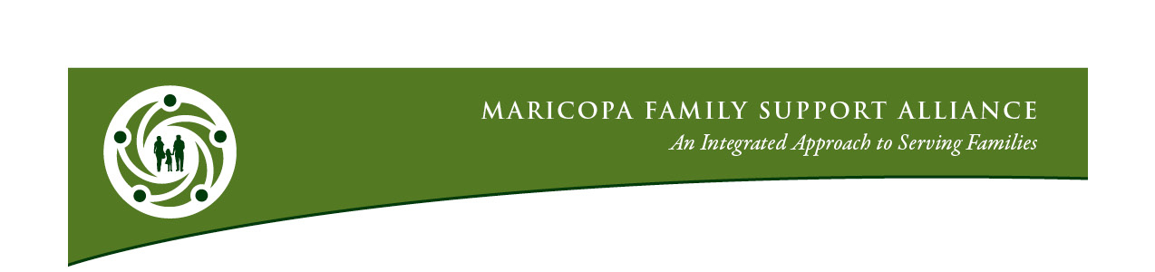

November 8, 2019
MFSA All Member Agency Meeting: 9:00 am to 11:30 am

Pre-meeting Orientation | Kristin Borns & Participating Agencies  (8:30-9)
Welcome | Julie Rosen, M.S., L.P.C., Child & Family Resources  (9-9:10)
Agenda Review & Meeting Objectives | Kristin Borns, Borns Solutions AZ  (9:10-9:15)
MFSA Social Network Analysis Survey Findings | Emily Mead, ISC  (9:15-9:45)
MFSA Reflection on Survey Findings | All  (9:45-10)
Utility Assistance Update | Cynthia Zwick, Wildfire  (10-10:35)
Census 2020 | Jannah Scott, U.S. Census Bureau  (10:35-10:40)
Networking Opportunity | All  (10:40-10:55)
Legislative Preview | David Lujan Esq., The Arizona Center for Economic Progress  (10:55-11:25)
Announcements | Carol Lopinski, Carol Lopinski and Associates, LLC  All  (11:25-11:30)
Evaluation & Adjournment

Next All Member Meeting
Friday, February 7, 2020

