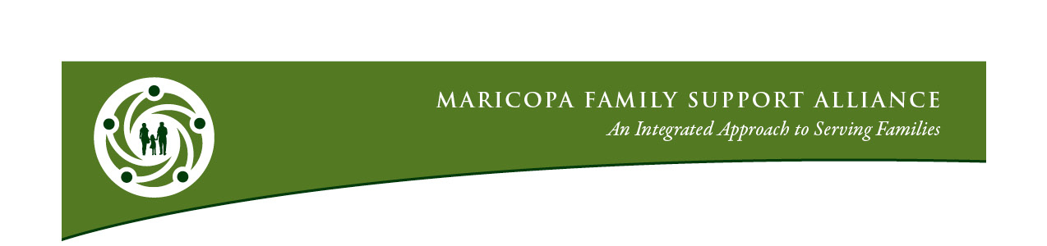

August 16, 2019
MFSA All Member Agency Meeting: 9:00 am to 11:30 am

Pre-meeting Orientation | Kristin Borns & Participating Agencies  (8:30-9)
Welcome | Emily Mead, Institute for Sustainable Communities  (9-9:10)
Agenda Review & Meeting Objectives | Kristin Borns, Borns Solutions AZ  (9:10-9:15)
MFSA Social Network Analysis Survey Findings Preview | Shawn Donnelly, Virginia G. Piper Charitable Trust  (9:15-9:30)
Father Engagement in Family Support | Carol Lopinski, Carol Lopinski & Associates, LLC  Neil Tift, Native American Fathers and Families Association  Kevin Poleyumptewa, NCJTC  Marion Hill, Head Start Birth to 5 Program, M.A.N. C.A.V.E.  (9:30-10:30)
Networking Opportunity | All  (10:30-10:45)
Arizona KIDS COUNT Data | David Lujan Esq., The Arizona Center for Economic Progress  (10:45-11:15)
Standards Training Update | Carol Lopinski, Carol Lopinski & Associates, LLC  (11:15-11:20)
Announcements | All  (11:20-11:30)
Evaluation & Adjournment

Next All Member Meeting
Friday, November 8, 2019

