www.ArizonaAtWork.com

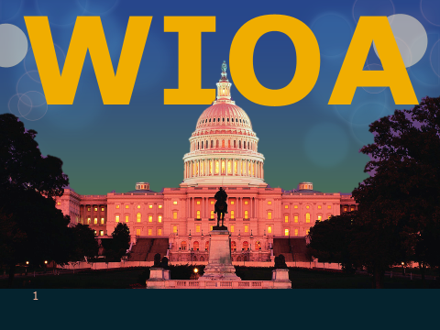

What is Workforce Innovation and Opportunity Act?

Overview of WIOA
The Workforce Investment Act (WIA) was authorized in 1998.
Over the past 11 years the public workforce system has long awaited reauthorization that would address the evolving workforce and economic needs as well as the limitations in WIA such as;
- Training
- Funding
- Service delivery design

The Workforce Innovation and Opportunity Act (WIOA) replaces WIA and will be in effect for five years (2015-2020).

Why WIOA?
WIOA was created to provide state and local areas the flexibility to collaborate across systems.
This effort addresses the employment and skills needs of current employees, jobseekers, and employers.
WIOA accomplishes this by prescribing:
- A stronger alignment of the workforce, education, and economic development systems;
- Improving the structure and delivery in the system to assist America’s workers in achieving a family-sustaining wage while providing America’s employers with the skilled workers they need to compete on a global level.

Wagner-Peyser
Provides employment and training services to employers and individuals seeking new jobs, better jobs or first jobs.

Participants are able to locate and retain suitable jobs and build sustainable careers
Services include:
- Resume development
- Job clubs
- Interview skills
- Job matching, and
- Career exploration

Adult Program
Provides workforce investment activities that increase the employment, retention, and earnings of adults ages 18 and older.
Improve the quality of the workforce, reduce welfare dependency, and enhance the productivity and competitiveness of the nation’s economy.

All adults must:
- Be U.S. citizens or lawfully admitted permanent resident aliens, refugees, asylees, parolees or other immigrants authorized to work in the United States.
- Meet Selective Service Registration requirements, if applicable.

Youth Program
Designed to prepare Arizona’s youth to enter either post-secondary education, training or employment upon completion of secondary education.

Serves Out-of-School Youth (ages 16 -24) and In-School Youth (ages 14-21)
Must meet income requirement, if required and have at least 1 of 8 specified barrier to employment:
- School dropout.
- Basic skills deficient.
- English language learner.
- Pregnant or parenting.
- Homeless, runaway, or foster child.
- Ex-offender.
- Disability.
- Requires assistance to complete an educational program, or to secure and hold employment.
Youth Program Services include:
- Tutoring, training, and instruction for completion of secondary school
- Mentoring
- Work experience (internships, apprenticeships, job shadowing)
- Occupational skills training
- Leadership development
- Supportive services
- Guidance counseling

What does WIOA do for people with disabilities?
WIOA includes amendments to the Rehabilitation Act of 1973 which significantly impact people with disabilities. As amended over the years, the Rehabilitation Act authorizes grants for vocational rehabilitation programs, supported employment, independent living, and client assistance.

Additionally, it authorizes training and service discretionary grants administered by the Rehabilitation Services Administration.
https://www.thearc.org/document.doc?id=5183

The WIOA Title IB Dislocated Worker (DW) program
- Provides workforce related core, intensive and training services to individuals who have been terminated through no fault of their own, laid off, or have received notice of termination or layoff, from employment generally due to plant closures or downsizing.
- Self-employed individuals who are unemployed due to general economic conditions and individuals who meet the WIOA definition of a displaced homemaker may also be eligible for services.

www.arizonaatwork.com
Equal Opportunity Employer/Program • Under Titles VI and VII of the Civil Rights Act of 1964 (Title VI and VII), and the Americans with Disabilities Act of 1990 (ADA), Section 504 of the Rehabilitation Act of 1973, the Age Discrimination Act of 1975, and Title II of the Genetic Information Nondiscrimination Act (GINA) of 2008; the Department prohibits discrimination in admissions, programs, services, activities, or employment based on race, color, religion, sex, national origin, age, and disability. The Department must make a reasonable accommodation to allow a person with a disability to take part in a program, service, or activity. For example, this means if necessary, the Department must provide sign language interpreters for people who are deaf, a wheelchair accessible location, or enlarged print materials. It also means that the Department will take any other reasonable action that allows you to take part in and understand a program or activity. If you believe that you will not be able to understand or take part in a program or activity because of your disability, please let us know of your disability needs in advance, if at all possible. To request this document in alternative format or for further information about this policy, contact your local office manager; TTY/TDD Services: 7-1-1. • Free language assistance for DES services is available upon request.

